NAME _______________________________CLASS______ ADM NO. ………..
2022 FORM 4 TERM 1 OPENER EXAM- (APRIL 2022)
232/1
PHYSICS
PAPER 1
(THEORY)
TIME: 2 HOURS

INSTRUCTIONS TO CANDIDATES
- The paper consists of two sections, Section A and B.
- Answer ALL the questions in section A and B in the spaces provided.
- ALL answers and working MUST be clearly shown.
- Mathematical tables and electronic calculators may be used.
SECTION A (25 MARKS)
Answer ALL the questions in this section in the spaces provided.
- A micrometer screw gauge is used to measure the thickness of a stuck of 10 microscope slide cover slips. The reading with the cover slips in position is as shown in figure 1.
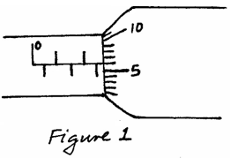

If the micrometer screw gauge has a negative zero error of 0.01mm, determine the thickness of each cover slip. (2 marks)

____________________________________________________________________________

____________________________________________________________________________

____________________________________________________________________________

____________________________________________________________________________

2.Explain briefly why water will wet a glass surface but mercury will not. (2 marks)
____________________________________________________________________________________________________________________________________________________________________________________________________________________________________________________________________________________________________________________________________________
3. The figure below is that of a uniform meter rule supported at the 30cm. A load of 5N is attached at
the 0cm mark and that of 2N to a pulley at the 100cm mark. Calculate the weight of the meter rule. (3 marks)
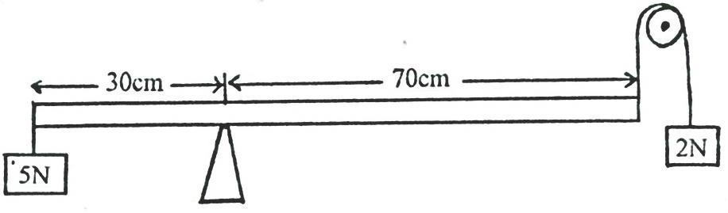

4. A mercury barometer reads 75cmHg at the base of Mt.Kenya. Assuming that the height of
the mountain is 1088m and the average density of air is 1.25kg/m³. What is the reading of the
barometer at the top of the mountain? (Take density of mercury is 13.6g/cm³.) (3 marks)

- The figure below is a rectangular block in a stable equilibrium, with a hollow section as shown. 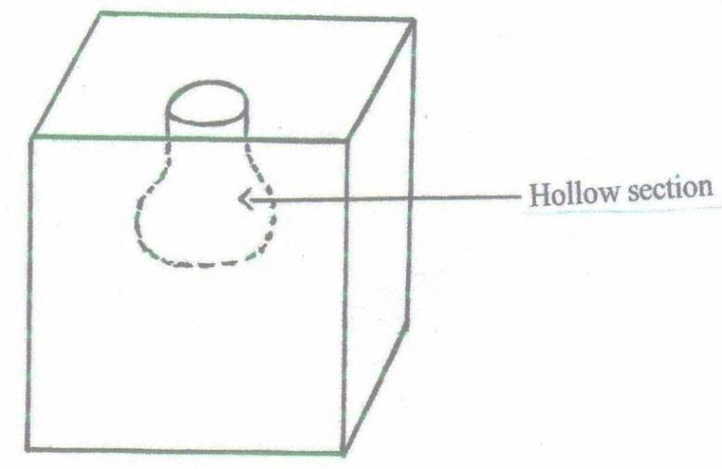
Hollow section
- What is the effect of adding water into the hollow section? (1 mark)
______________________________________________________________________________________________________________________________________________________________________
- What could be the reason for your answer above? (2 marks)
______________________________________________________________________________________________________________________________________________________________________6. The figure below is that of identical springs. A 60N weight is attached on the springs as shown
so that the total extension for the system is 6cm. Calculate the spring constant of one spring. (3 marks)
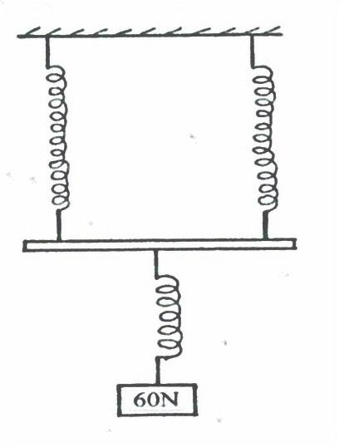
60N

6.The system in the figure below is in equilibrium at room temperature. The system is taken
outside where the temperature is 10⁰C higher for some time.
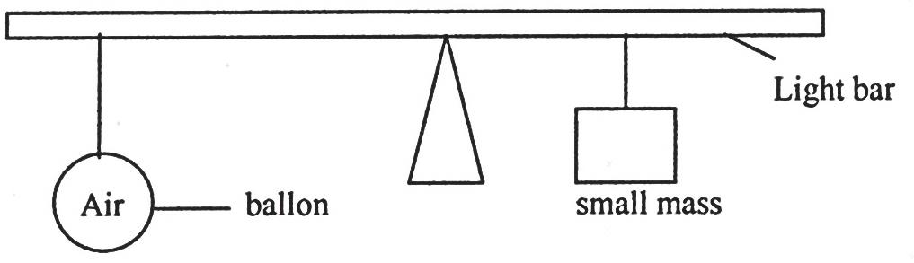
Balloon
Small mass
Light bar
Explain why it tips to the right when it is taken outside the room. (2 marks)
____________________________________________________________________________________________________________________________________________________________________________________________________________________________________________________________________________________________________________________________________________
- State one way of increasing sensitivity of mercury in glass thermometer. (1 mark)
______________________________________________________________________________________________________________________________________________________________________
- A tightly fitted bottle cork will be easier to remove if the bottle is warmed.
Explain this using kinetic and thermal property of matter. (2 marks)
____________________________________________________________________________________________________________________________________________________________________________________________________________________________________________________________________________________________________________________________________________
- A bullet of mass 20g moving with a velocity of 30m/s penetrates a sand bag and it’s brought
to rest in 0.05 seconds. Find the average retarding force of the sand. (3 marks)

- Explain why an iron gate feels colder when touched but its wooden gatepost feels warm at night. (1 mark)
_________________________________________________________________________________________________________________________________________________________________________________________________________________________________________________________
SECTION B (55 MARKS)
Answer ALL the questions in this section in the spaces provided.
- a) Distinguish between streamline and turbulent flow. (2 marks)
____________________________________________________________________________________________________________________________________________________________________________________________________________________________________________________________________________________________________________________________________________
b) The figure below shows two light sheets of paper arranged as shown.
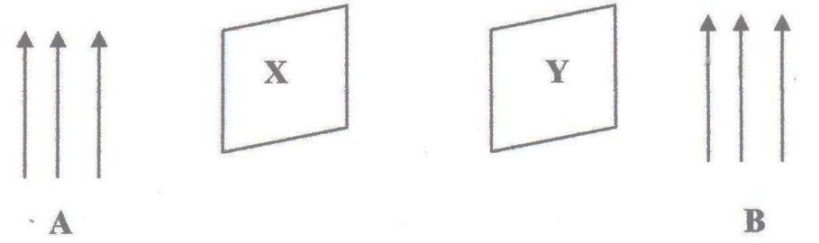
Y
X
B
A
Explain the observation made when air is blown at the same speed and time at points A and B. (2 marks)
_________________________________________________________________________________________________________________________________________________________________________________________________________________________________________________________

- The figure below shows an incompressible fluid moving through a tube of varied cross- sectional area. If the area of the small tube is 0.05m², calculate the diameter of the large tube in cm. (3 marks) 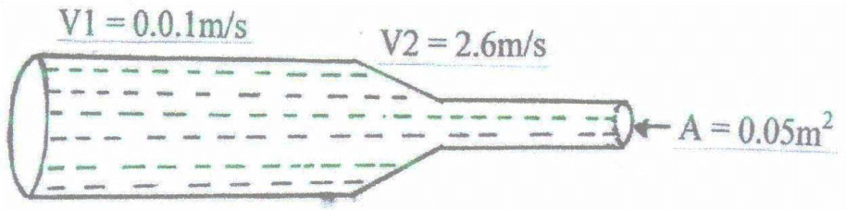
V₁ = 2.6 m/s
A = 0.05 m²
V₁ = 0.01 m/s

- Use the figure below to answer the questions that follow.
Gas in
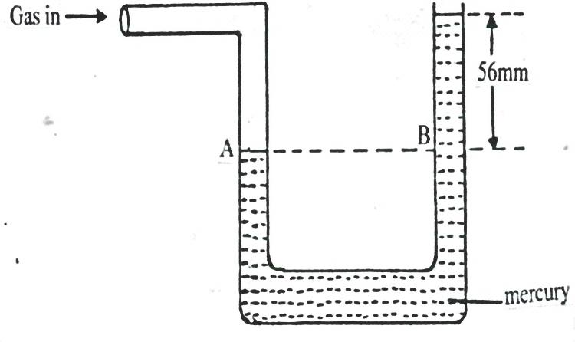
56mm
B
A

Mercury
- What pressure is acting on point A? (1 mark)
___________________________________________________________________________________
- What is the value of pressure difference in the instrument reading? (1 mark)

- If the atmospheric pressure is 760mm of mercury, what is the value of gas pressure? (2 marks)

- In an experiment to estimate the size of oil molecule an oil drop of diameter 0.05cm spreads over
water to form a circular patch whose diameter is 15cm.
a) Explain why the oil spreads over water. (1 mark)
______________________________________________________________________________________________________________________________________________________________________
b) Determine:
i) Volume of the drop. (3 marks)

ii) Area of the patch. (3 marks)

c) State two assumptions made in b)(ii) above. (3 marks)
___________________________________________________________________________________
______________________________________________________________________________________________________________________________________________________________
13. The figure below shows a velocity – time graph for the motion of a certain body.
Describe the motion of the body in the region:
- OA: (1 mark)
______________________________________________________________________________________________________________________________________________________________________
- AB: (1 mark)
______________________________________________________________________________________________________________________________________________________________________
- BC: (1 mark)
______________________________________________________________________________________________________________________________________________________________________
b) A car moving initially at 10m/s decelerates at 2.5m/s²
Determine:
- I) Its velocity after 1.5seconds. (2 marks)

II) distance travelled in 1.5 seconds. (3 marks)

- The time taken for the car to stop. (3 marks)

- Sketch the velocity – time graph for the motion of the car up to the time the car stopped. (1 mark)

- From the graph determine the distance the car travelled before stopping. (2 marks)

14. a) A machine is a device that enables work to be done more easily and conveniently. State any two ways in which a machine makes work easier. (2 marks)
……………………………………………………………………………………………………………………………………………………………………………………………………………………………………………………………………………………………………………………………………………………………………………………………………………………………………………………………………………………………………………………………………………………………………………………………………………………………………………………
b) Figure 7 shows a wheel and axle being used to raise a load W by applying an effort E. The radius of the wheel is R and of the axle is r.

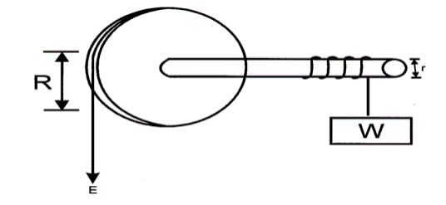
i) Show that the velocity ratio (V.R) of this machine is given by (3 Marks)
………………………………………………………………………………………………………………………………………………………………………………………………………………………………………………………………………………………………………………………………………………………………………………………………………………………………………………………………………………………………………………………………………………………………………………………………………………………………………………………………
ii) Given that r = 5cm and R = 50cm, determine the effort required to raise a load of 200N if the efficiency of the machine is 90%. (3 mks)
………………………………………………………………………………………………………………………………………………………………………………………………………………………………………………………………………………………………………………………………………………………………………………………………………………………………………………………………………………………………………………………………………………………………………………………………………………………………………………………………
(C). State two reasons the efficiency of any given machine less than 100% (2mks)

15. (a) State Hooke’s Law. (1mk)
…………………………………………………………………………………………………………
…………………………………………………………………………………………………………
(b) The figure below shows the variation force with extension for a steel coil spring.
(i) On the same axes, sketch the variation of force with extension for a wire from which the spring
Force N
Extension cm
is made. (1mk)

ii). Explain the difference between the two lines drawn (2mks)
…………………………………………………………………………………………………………
………………………………………………………………………………………………

(iii) The following results were obtained in a experiment to verify Hooke’s law when a spring was
extended by hanging various loads on it.

Load (N) | 0.00 | 1.00 | 2.00 | 3.00 | 4.00 | 5.00 | 6.00
Length of spring in cm | 10.00 | 11.50 | 13.00 | 14.50 | 16.00 | 18.00 | 24.00
Extension | 0.00
Complete the table for the extension e above. (1mk)

(iv) Plot a graph of load (y-axis) against extension (3mks)

(v) From the graph determine the springs constant. (2mks)

